**Sprint 1 Report**

**Plan-it**

**Team Rocket**

**10/21/19**

**Actions to Stop Doing:**

* Team Rocket will stop using Spreadsheets as a way for developers to claim tasks. Using spreadsheets isn’t the best option to demonstrate an agile software development. Team will switch over to ClubHouse.

**Actions to Start Doing:**

* Team Rocket should become more familiarized with ClubHouse as that will be our virtual scrum board. ClubHouse will help our team members keep track of our goals and tasks completed before the deadline of next Sprint.
* Team Rocket should start pulling from GitHub repository at least once a day to ensure each team member has looked at any recent changes.

**Actions to Keep Doing:**

* Meeting on Monday, Wednesday, Friday at 11:30 is working well for everyone. This time fits with everyone's schedule and conveniently takes place right before class.
* Standing up during our scrum meeting keeps team members focused on what each of us have completed since the last meeting and encourages everyone to participate in the meeting.
* Communicating via text group chat prevents merging issues, keeps us informed, and helps us stay organized with our tasks.

**Work Completed/ Not Completed:**

-Implemented user input, data editing, and displays list of activities in a table.

- Program calculates total time and cost of activities.

- Put together the UI with resizable windows, buttons, and graphics.

- Still need to implement mysql as the main database for the program which will be

which will be automatically updated each time user inputs adds a new activity.

- Need to figure out best algorithm to sort activities and add them to the plan based on cost

and time.

**Work Completion Rate:**

User stories completed: 2/2

Total ideal work hours: 25 (not counting presentation, reports, etc.)

Total days in Sprint: 14

Ideal work hours/day: 1.8

User stories/day: 0.14

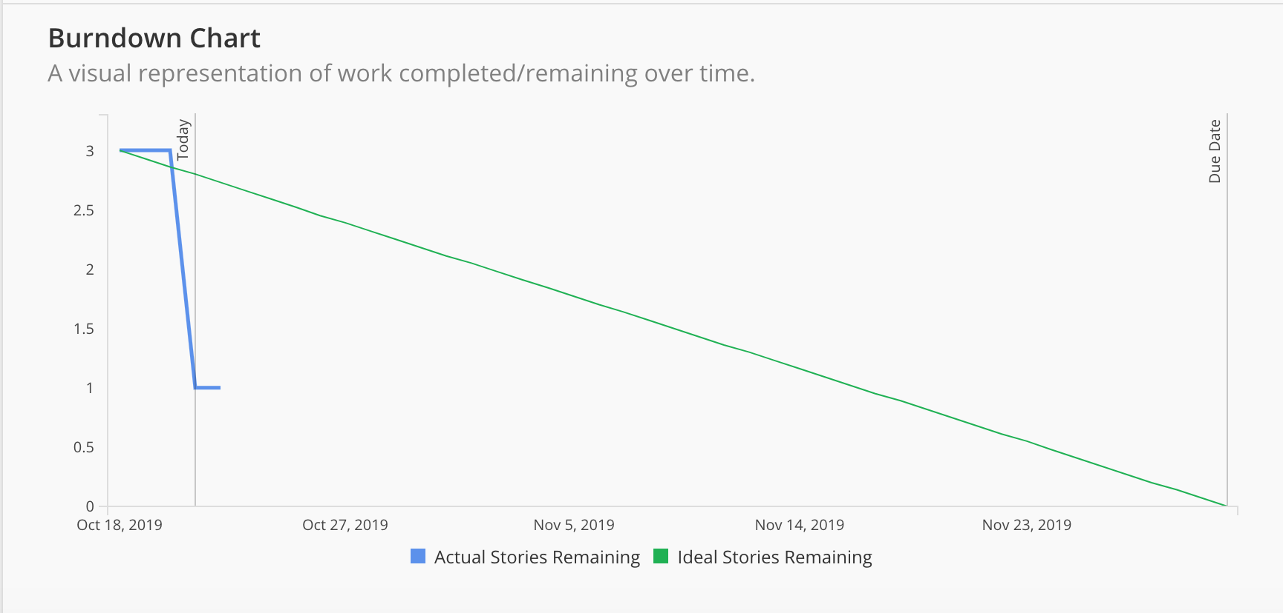

(Start times not accurate, since we only switched to ClubHouse recently)